The inverted U relationship between green innovative activities and firms’ market-based performance: the impact of firm age

Abstract
Despite the growing interest in environmental innovations, there is still no consensus about their effect on firm performance. On the one hand, advocators of environmental innovations state that such innovations exert a positive influence on firm performance, as they can reduce production costs, open new markets and improve a firm’s corporate image, among other benefits. On the other hand, environmental innovations are associated with relevant drawbacks such as high development costs and uncertainties, leading some authors to establish a negative relationship. We try to shed light on this debate by stating that this relation is more complex than a simple linear association; hence, we propose an inverted U relationship between environmental innovations and firm performance. In addition, we claim that firm age plays a key role in that relationship, as more mature firms find it more difficult than younger firms to capitalize on environmental innovations to improve firm performance. Our longitudinal analysis of 4,634 environmental patents from 75 companies belonging to the electrical components and equipment industry worldwide confirms our hypotheses.

Keywords:
Environmental innovation; sustainable development; financial performance; firm age; longitudinal analysis; patents.
INTRODUCTION
Environmental innovations are becoming an increasingly salient topic. Governments all over the world are establishing these innovations as a priority in their political agendas (Bai, Song, Jiao, & Yang, 2019; European Commission, 2019) in the hope that environmental innovations will not only reduce ecological impacts but also generate valuable competitive advantages (Aragon-Correa, Marcus, & Vogel, 2020; Bohnsack, 2018). For example, the European Union has established environmental innovations as a cornerstone in its innovation strategy (European Commission, 2019), and China is subsidizing environmental innovation technologies in a variety of strategic sectors, such as the automobile and energy industries (Bai, et al., 2019). In addition, companies are making greater effort to develop these technologies as a response to consumers’ increasing demands for environmentally friendly products and services, such as renewable energy solutions (e.g., Standard & Poor, 2019). As such, the global market of environmental innovations and sustainability is forecasted to grow from $8.7 billion in 2019 to $28.9 billion by 2024, which represents an annual 27.1% increase (Business Wire, 2019).
Environmental innovations can be defined as “measures of relevant actors, which: (i) develop new ideas, behavior, products and processes, apply or introduce them, and (ii) contribute to a reduction of environmental burdens or to ecologically specified sustainability targets” (Rennings, 2000: 322). However, despite this growing interest toward environmental innovations, works have not reached a consensus about their net effect on performance, thus nurturing an intense debate on this subject (Ghisetti & Rennings, 2014). Advocators argue that environmental innovations can be positive not only for the environment but also for firm performance (Caviggioli, 2016; Chen, 2008; Dangelico, 2016). On the other hand, other studies have shown no relation or even a negative relationship between a firm’s environmental innovation and the firm’s performance (Driessen, Hillebrand, Kok & Verhallen, 2013; Hussain, Rigoni, & Cavezzali, 2018). In this regard, we try to shed some light on this debate by arguing that the relationship between environmental innovation and firm performance is more complex than the traditionally argued linear relationship. More specifically, we propose that the relationship has an inverted U shape. That is, a moderate and advanced use of environmental innovations yields positive results for the company, but “excessive” use of these innovations potentiates their negative aspects such as complexity and uncertainty, hence generating a negative marginal effect for the company.
To complement previous ideas, we should not ignore the fact that as companies mature over time, the relationship between the introduction of environmental innovations and firm performance may change. In other words, firm age is a contingency that can alter the nature of the proposed relation (D’Amato & Falivena, 2019; Leoncini, Marzucchi, Montresor & Rentocchini, 2019). The firm life cycle suggests that firms go through different stages of organizational development as time goes by and that can alter the returns they obtain from their innovative activities (Coad, Segarra & Teruel, 2016). As a result, previous studies point out that age is a factor that could impair firm performance, as it brings about inertia and rigidities that lower flexibility and discourage change. Thus, it can be more challenging for older firms to identify valuable signals and innovation opportunities in the environment (Hannan & Freeman, 1984; Leonard-Barton, 1992; Rossi, 2016). To extend current research, in this study, we evaluate the impact that firm age has on the relationship between environmental innovation and firm performance.
Based on previous arguments, we address the following research questions: Is there an inverted U-shaped relationship between green innovative activities and firms’ market-based performance? And how does firm age moderate this relationship? To answer these questions, we conduct a longitudinal analysis over the period of 2006-2009 of 75 companies from the electrical components and equipment industry worldwide, resulting in a total of 4,634 environmental patents analyzed. Our results show that the relationship between environmental innovation and firm performance goes beyond a simple linear trend, thus showing an inverted U relationship. Additionally, our study analyzes the key role played by firm age in this relationship. In particular, we show that more mature firms have more difficulty capitalizing on environmental innovations to improve firm performance than younger firms. In other words, younger firms may “flatten” the negative curvilinear relationship between environmental innovations and firm performance.
Our work makes several contributions to the literature. First, we contribute to the debate about the convenience (or inconvenience) of sustainable strategies for better firm performance (e.g., Ghisetti & Rennings, 2014) by analyzing environmental innovations. Previous studies have attempted to address this issue by employing several measures of sustainability performance, such as reputation indexes, environmental practices disclosure, corporate philanthropy, analyses of sustainability reports, etc. While these works show a plausible effort to understand the complex nature of sustainability, the measures employed may not be as narrowly defined and comparable as environmental patents. For instance, in their remarkable analysis of sustainability reports, Hussain et al. (2018) recognize that the variables employed “are broad, [and] not verifiable, measures of firm sustainability disclosure” (p.1202). Similarly, Berrone, Fosfuri, Gelabert, & Gomez–Mejia (2013) recommend analyzing environmental innovations with patents instead of questionnaire surveys, as they consider that the latter “could be seriously biased as respondents may tend to present a socially desirable image of themselves or their companies” (p.892). Second, by focusing on environmental innovations, we contribute to the emerging research that calls for a better understanding of such innovations (e.g., Berrone, et al., 2013; Dangelico, 2016). More specifically, we answer Lee & Min’s (2015) assertion that “more research on the impact of eco-innovation on firm performance is needed” (Lee & Min, 2015: 535). We do so by going beyond the linear relationship proposed in previous literature and proposing more complex relations that may provide us with a more nuanced understanding of the phenomenon. In this way, we also answer Dangelico’s (2016) call to “deepen our knowledge […] and understand [when] sustainability innovations lead to high performance” (Dangelico, 2016: 573). Finally, our research also accounts for the differential effects that environmental innovations have on firm performance when considering the firm age, hence extending the scarce literature that has started paying attention to the role of firm maturity in the development of environmental innovations (Leoncini et al., 2019).
THEORETICAL DEVELOPMENT
While the analysis of environmental innovations is relatively new, the debate about the convenience (or inconvenience) of pursuing a sustainable strategy is far from new (Porter & Van der Linde, 1995). On one hand, advocators of sustainability argue that a proactive environmental strategy yields positive firm performance due to achieving a better image (Chen, 2008), producing the opportunity to open a new market (Beise & Rennings, 2005), more easily adapting to stricter regulations (Aragon-Correa, et al, 2020), etc. On the other hand, detractors of a sustainability approach state that this orientation hinders a firm’s profitability, as it poses higher development costs (Bai et al., 2019), adds bureaucratic burdens (e.g., environmental certifications; Delmas, 2002), and requires resources that could be deployed for other activities (Hussain et al., 2018). In this regard, we aim to contribute to the longstanding debate, “does it pay-off to be green”, by conducting a more profound analysis of environmental innovations.
The relationship between environmental innovation and firm performance
Current concerns about sustainability issues (e.g., United Nations (UN) COP21 Paris Agreement, increasing activism toward climate change, environmental scandals, etc.) have given environmental innovation major importance in the competitive arena. For example, the UN agreement on climate change signed in 2015 in Paris stands on the commitment toward a 2-degrees Celsius maximum temperature increase by the end of this century (UN, 2016). According to the agreement, keeping the current production system will result in an increase of more than 4 degrees Celsius (UN, 2016); thus, to achieve the intended goal, it is vital to introduce major changes, such as the development of environmental innovations. Likewise, the European Union framework program for research and innovation has explicitly set environmental innovations as a key pillar of its strategy (European Commission, 2019). Additionally, traditionally polluting countries are incentivizing green innovations; for example, China is offering R&D subsidies for green innovations to achieve its goal of a 40%-50% reduction of CO₂ levels by 2020 compared to those in 2005 (Bai, et al., 2019). In this regard, such institutional support for environmental innovations enhances their competitive advantages, hence increasing the profitability of such technologies. Just for illustration, Bai et al.’s (2019) longitudinal analysis of Chinese energy-intensive firms showed that current policy support for environmental innovations clearly reduced these firms’ development costs and enhanced their competitive advantages, which resulted in significant increases in firm performance. More specifically, they stated that ““[g]overnment R&D subsidies can reduce the costs and stimulate green innovation tendency” (Bai et al., 2019: 825).
In addition, market forces spur the development of environmental innovations. For example, Henriques & Sadorsky’s (1996) study on large corporations showed that consumers are willing to pay a higher price for environmentally friendly products. This idea was corroborated by Manget, Roche & Münnich’s (2009) study, which found that consumers in Northern America (Canada & the U.S.), Japan and European countries (France, Germany, Italy, Spain, and the U.K.) were willing to pay more for greener products. In other cases, companies can create a market for sustainable innovations where there is not such a market. Aragon-Correa’s (1998) seminal work on sustainability clearly shows that proactive environmental companies can generate a new market for more environmentally friendly products. In the case of environmental innovations, Toyota’s decision to create a hybrid vehicle (an innovation that could be considered environmental when compared to traditional combustion engine cars) opened a new market that positioned it as a global leader, which continues today (Toyota, 2017).
However, the advantages of environmental innovations are not unlimited, since “excessive” development of these innovations may be detrimental to the company’s profitability. This turning point is due to several factors such as the complexity, uncertainty and radicalness of this type of innovation (Cainelli, De Marchi, & Grandinetti, 2015; Leyva-de la Hiz, Ferron-Vilchez, & Aragon-Correa, 2019). Environmental innovations tend to be more complex than non-environmental innovations, as they require managing interrelations between legal requirements, environmental technologies, manufacturing and administrative processes, etc. (del Brío & Junquera, 2003). Further, this multidimensionality of environmental innovations implies that skills in distant domains and knowledge exchanges between different sources tend to be more predominant for environmental innovations than for other technological innovations (Ghisetti & Rennings, 2014). Environmental innovations tend to be more radical than non-environmental ones, as continuously reducing environmental burdens requires going beyond well-known and already exploited domains. In other words, environmental innovations need to explore new domains since matching current pollution levels, for example, is no longer an environmental innovation. Consistent with these ideas, Barbieri, Marzucchi and Rizzo (2020), in a longitudinal study based on a large sample of patents, showed that green technologies are more novel and radical than non-green technologies, as they usually represent a technological frontier and imply significant changes given the lack of technological trajectories. Not surprisingly, green innovations combine more diverse and novel technological inputs and components and rely on more varied sources than their non-green counterparts.
In this sense, lower levels of environmental innovation development (e.g., pollution reduction) may not constitute a major effort by the organization because the associated skills and areas are relatively close and easy to manage. However, as an environmental innovation develops further (e.g., raw material minimization and energy optimization), so it does its complexity and interconnectivity with different areas, hence increasing coordination costs to the point that they exceed the economic benefits that the environmental innovation confers. In this realm, environmental innovations require exploring new technological frontiers that are outside of well-known traditional technologies. This explorative nature, while promising, entails significant risks for the company’s profitability, as exploration involves costs that do not guarantee success (March, 1991). Again, relatively low levels of development require minor costs of exploration; hence, the benefits may outweigh such costs. However, as environmental innovations become more developed, it becomes necessary to increase efforts toward discovering new knowledge such that the costs may exceed the benefits. This explorative cost has to be added to the increasing coordination cost of combining different areas, departments, etc. For this reason, some scholars do not recommend devoting the totality of a firm’s resources to exploring new technologies but suggest combining them with more secure, better-known technologies (Derbyshire, 2014; Enkel, Heil, Hengstler, & Wirth, 2017). Further, even if firms focus on a single or a few areas, where coordination costs are lower and their prior experience in the focused area might help reduce their costs, firms cannot exploit well-known areas sine die and expect continuous environmental progress. At some point, environmental improvement will reach a maximum, and going beyond that level will require radical changes. This intrinsic radicalness of environmental innovations is a factor that can increase the uncertainties and risks related to such innovations (Hansen, Søndergard & Meredith, 2002). As Cecere, Corrocher, Gossart & Ozman (2014) point out, in an eco-innovative context, as firms face radical technological changes, they may struggle to remain competitive in the market because they have to adapt their original capabilities and competencies to the new context, which may not be certain.
Finally, one of the advantages of environmental innovations, policy support (Aragon-Correa et al., 2020), should not be taken for granted. In this sense, environmental innovations depend more on external policies than nonenvironmental technologies do (Bai et al., 2019; Leyva-de la Hiz, 2019; Walsh, 2012). In this regard, a number of scholars state that one of the key successes of the development of environmental innovations such as clean electricity was the introduction of feed-in tariffs, i.e., a fixed price for electricity guaranteed by the government (Jaffe, Newell, & Stavins, 2002; REN21, 2011), which is a policy that has been pursued by a large number of countries (REN21, 2011). However, despite this global tendency toward stronger regulations that favor the development of environmental innovations, in some cases, policies are not very munificent, a good example of which the current U.S. downturn in environmental policy (Bloomberg, 2019). Recent U.S. policies support a reduction in the budget allocated to the U.S. Clean Energy Research division, a division that makes efforts to improve the efficiency of wind power and electric cars, among other environmental technologies, from its initial $2.3 billion budget to $700 million (Bloomberg, 2019).
Given these particularities of environmental innovations, we consider that the relationship between such innovations and performance is much more complex than a linear positive or negative association. In this regard, we argue that while environmental innovations pose many advantages, they also encompass some disadvantages that may encourage firms to avoid full commitment to such innovations; thus, we propose an inverted U relationship between environmental innovations and firm performance. We argue that the introduction of environmental innovations can bring considerable benefits for firms, such as first-mover advantages, increased firm reputation and new market opportunities, inducing higher performance results. However, as environmental innovations become more developed, so it does their complexity, the need to coordinate efforts between different departments, and the need to explore uncertain technological areas; hence, the cost of environmental innovations may outweigh their benefits. Consequently, we propose the following:
H1. There is an inverted U-shaped relationship between the development of environmental innovations and firm performance.
The moderating effect of firm age on the relationship between the development of environmental innovations and firm performance
Age is a characteristic of firms that influences their experience, resources, relationship with stakeholders, reputation, strategic position, and market share (D'Amato & Falivena, 2019). In this regard, previous literature has considered firm age to be a contingency that can significantly affect organizational outcomes, such as corporate social initiatives (Withisuphakorn & Jiraporn, 2016) and innovation (Balasubramanian & Lee, 2008; Tripsas & Gavetti, 2000). It is thus important to take into account that younger and more mature firms present different features that determine their ability to launch new products into the market, develop socially responsible practices, or capitalize from new discoveries to increase financial results (Withisuphakorn & Jiraporn, 2016). For this reason, some studies in the innovation literature have explored how age moderates firms’ capacity to turn innovation efforts into performance (Balasubramanian & Lee, 2008; Coad et al., 2016), yet these studies have also found contradictory results. Moving forward, we try to elucidate these opposing conclusions by analyzing the moderating effect of age in the context of environmental innovations. More specifically, we want to assess whether the nonlinear relationship proposed between environmental innovations and firm performance varies as firms evolve and mature over time.
Different authors indicate that younger firms may face important disadvantages that hinder them from fully benefiting from innovation investments (Coad, Segarra & Teruel, 2013; Helfat & Peteraf, 2003). In this sense, younger firms usually have a lower absorptive capacity to acquire and exploit external knowledge flows (Zahra & George, 2002), which decreases their ability to make the most of such inputs in innovating, in part because of their lack of complementary resources (Bolívar-Ramos, 2017). As companies age, they learn and thereby improve their ways of doing things, develop dynamic capabilities, increase their ability to survive, and achieve greater profits over time (Rossi, 2016). For instance, in a sustainable context, established companies such as Microsoft, Intel, and General Motors have made significant efforts toward environmental leadership that have led to greater profits compared to their peers (Forbes, 2019). Along these lines, authors such as D’Amato and Falivena (2019) have found that corporate social responsibility initiatives—e.g., those that promote environmental protection—may translate into higher financial results in more mature firms than in younger firms for the following reasons: first, younger firms tend to experiment with more volatile cash flows, having fewer resources to develop socially responsible initiatives; second, older firms can benefit from more firm-specific human capital derived from past experience; and third, more mature firms have had more time to consolidate their reputations regarding these types of practices.
However, although older firms may become more dominant over their surroundings, they also become less able to face and respond to new challenges due to organizational inertia (Hannan & Freeman, 1984; Kücher, Mayr, Mitter, Duller & Feldbauer-Durstmüller, 2018; Rossi, 2016). Recently, we have witnessed young firms’ success in this area; for example, SolarEdge Technologies (founded in 2006) has not only introduced leading innovations in solar optimizers and inverters —winning several awards— but also become one of the top 10 largest companies that derive the majority of its revenues from renewable energies, with a market capitalization of $3.9 billion (Finance Yahoo, 2019). In this sense, younger firms may pursue riskier and more promising environmental opportunities than more mature firms since incumbents may be more hesitant to develop “green strategies” and introduce sustainable products that could cannibalize their existing products (Nicholls & Opal, 2005). This, in turn, could imply that the environmental innovations introduced by more mature firms may not be too different or more radical than their traditional portfolio, leading to a lower impact on firm performance (Shrivastava & Tamvada, 2019). In addition, mature firms usually suffer greater rigidities, which ties them to the familiar knowledge they possess, whereas younger firms are usually more capable of exploiting nascent technologies (Petruzzelli, Ardito & Savino, 2018), such as environmental technologies—in many cases, related to emerging fields (Horbach, 2016). Consequently, younger firms may reap more benefits from environmental technologies with great profitability potential compared to older firms that, in turn, will experience more pronounced declining effects on performance for high levels of environmental innovation.
As discussed previously, more mature firms usually possess greater technological resources, capabilities and competences, but these characteristics also constitute the base for their “path dependency”. Thus, commonly, they concentrate on exploiting such resources, rather than pursuing different technological trajectories (Kiefer, Del Rio Gonzalez, & Carrillo‐Hermosilla, 2019). In addition, newer firms have been found to possess an advantage on the environmental front over older firms, as they have more modern assets that include more energy-efficient manufacturing equipment and the latest environmental technologies (Balasubramanian, Shukla, Mangla, & Chanchaichujit, 2020; Tatoglu, Bayraktar, Sahadev, Demirbag, & Glaister, 2014). In other words, we contend that at high levels of environmental innovation, older firms may experience more declining benefits than newer firms because their rigidities and organizational inertia may make the eco-innovative process less disruptive and more likely to follow past routines (Elsayed, 2006), which can subsequently translate into missing profitable alternatives. Conversely, younger firms may be more proactive in exploiting new innovation opportunities (Huergo & Jaumandreu, 2004), which can activate green mechanisms that improve firm performance, such as via green differentiation advantages, eco-efficiency, or tapping green demand market segments (Leonci et al., 2019). In this case, even the negative effects derived from a high level of environmental innovation (such as increased costs) will still be mitigated by the flexibility and ability of younger firms to pioneer under these circumstances, making the fall in financial performance at this turning point weaker than in the case of more mature firms. It is worth pointing out that although the means versus variance thesis proposed by Fleming (2001) suggests that explorative behaviors, such as those in novel eco-innovations, are typically associated with lower average performance with greater variance, we contend that in the case of younger firms, the average effects may be explained because investors value more highly explorative innovations than exploitative ones. Notably, since younger firms need to increase their legitimacy to a greater extent than older firms, they are also more likely to obtain additional rewards from engaging highly in environmental conduct, which, in turn, improves stakeholders’ positive perceptions of their business (Balasubramanian et al., 2020; Welbeck, Owusu, Bekoe, & Kusi, 2017). This is also consistent with past research that shows that firms with superior explorative capabilities achieve higher firm value (Sarkees, Hulland & Chatterjee, 2014), which in this case applies to younger firms that possess less rigidities and path dependence than older firms.
Although the evidence is mixed, we propose that as firms mature, their ability to capitalize from developing environmental innovations to improve financial performance will be lower than that of younger firms. Thus, although increasing levels of environmental innovation can be positive for both younger and more mature firms, we expect that overemphasis of these type of innovations will bring more negative financial consequences for more mature firms than for younger firms, particularly with high levels of environmental innovation. Certainly, older firms can take advantage of more resources and previous learning to understand the multidimensionality of green technologies (Carrillo-Hermosilla, Del Río & Könnölä, 2010), but these firms will be more likely to follow past routines and fall into competency traps (Leonard-Barton, 1992), which discourages them from pursuing new green innovations to open up radical and profitable opportunities. Further, more mature firms use less up-to-date green equipment and technologies that they are usually unwilling to upgrade due to the risks and costs involved (Balasubramanian et al., 2020; Darnall, Henriques & Sadorsky, 2010). Thus, the literature has pointed out that younger firms are typically more flexible in capitalizing on novel knowledge for innovation (Petruzzelli et al., 2018), such as that behind the technologies involved in environmental innovations. Therefore, we contend that green product innovations may be more relevant to increasing firm performance in younger firms than in more mature companies (Shrivastava & Tamvada, 2019), with the latter also experiencing more pronounced falls in firm performance at high levels of environmental innovation. Thus, we hypothesize the following:
H2. Firm age negatively moderates the inverted U relationship between environmental innovations and firm performance, such that younger firms will have greater performance at low levels of environmental innovation and less pronounced declining effects at high levels of environmental innovation.
METHODS
Sample
We conducted a longitudinal analysis for the period of 2006-2009 with companies from the electrical components and equipment (E&E) sector (numbered 6190 in the COMPUSTAT database). In our sample, we selected companies with at least $1 million in net sales for two main reasons. First, this threshold is in line with previous works studying innovation (e.g., Peeters & de la Potterie, 2006). Second, we use patents as a proxy for innovation. This procedure is not only congruent with a large number of innovation studies (e.g., Huang & Su, 2019; Jeong & Yoon, 2015), but given that filing a patent tends to be costly in terms of time and money (Somaya, 2012), companies may need a certain level of sales to bear such costs. For our sector, we selected the E&E because it represents a high-competitive, highly globalized industry in which companies compete against each other for mass production of components and equipment, which explains why this industry ranks among the top patent producers according to the Patent Cooperation Treaty (Gurry, Fink, Khan, Bergquist, Lamb Feuvre, Le, & Hao, 2012). In other words, firms patent all their inventions to avoid competitors taking advantage of them, hence resulting in a “patent portfolio race” (Hall & Ziedonis, 2001). This situation makes patents a very robust proxy for measuring companies’ innovations. Regarding the period of time used in our analysis, the timeframe selected (2006-2009) represents a relatively stable technological and economic time for the E&E industry. From a technological point of view, this period spans a time well after the introduction of personal computers and before the widespread use of smartphones. From an economic point of view, this period is placed after the “.com bubble” burst in the year 2000 and before the real-estate crisis (2008-2010) that developed into a recession of global dimensions.
We retrieved patents from the Global Patent Index (GPI) of the European Patent Office (EPO) database. The GPI is one of the most comprehensive patent databases worldwide and contains patents from not only European companies but also companies headquartered in the U.S., Japan and South Korea, among others (GPI 2009, User Manual). Furthermore, given the highly international nature of our industry (Electrical Components and Equipment), we ensured a globally representative sample. With respect to the selection of environmental patents, the EPO database recently created a specific category for delimitating the patents that can be considered environmental from those without enough environmental progress, a procedure that is much more precise and reliable than abstract-based keyword analyses (e.g., Lee, Veloso, and Hounshell, 2011). After applying these criteria, and given that COMPUSTAT did not contain complete information for all companies, our final sample resulted in 4,634 environmental patents from 75 companies during the period 2006-2009, resulting in 232 firm-year observations (additional information is displayed in Table 1).
Measures
Our work is based on the following estimation equation (control variables omitted):
Firm performance = β₀ + β₁X₁ + β₂X₁² + β₃X₂ + β₄X₁X₂ + β₅ X₁²X₂ + ε
where X₁ represents a firm’s environmental innovation and X₂ represents the firm age.
Dependent variable.
Firm’s performance. In line with previous studies (Doidge, Karolyi, & Stulz, 2004; Loderer, Stulz & Waelchli, 2016), we employ Tobin’s Q for assessing market-based firm performance. Tobin’s Q is defined as the ratio between the firm’s market value and the replacement cost of its assets. This variable is especially appropriate for measuring firm performance, as it presents some advantages, including that a) it exhibits scale independence and robustness in relation to accounting manipulations (Ernst, 2001; Jayachandran, Kalaignanam & Eilert, 2013); b) in comparison with ROA, ROE, and other profitability measures, Tobin's Q is perceived as a better indicator of corporate performance and value, given that it reflects the future development expectations of the firm (Li, Liao & Albitar, 2020); and c) it accounts for intangible assets, which are an important component for technological companies, as the replacement cost of such intangibles tends to be much higher than the mere cost of tangible assets (Somaya, 2012; Varaiya, Kerin & Weeks, 1987). The fact that Tobin’s Q accounts for intangible assets and reflects the firm value has been applied in previous environmental literature to measure future firm performance (e.g., Jayachandran et al., 2013; Li et al., 2020). In this regard, Jayachandran et al.’s (2013) analysis on the relationship between corporate social performance and firm performance employs Tobin’s Q as a measure that “reflects future profitability” (p. 1259). In relation to the empirical calculation, we employ Chung & Pruitt’s (1994) procedure with the COMPUSTAT database.
Independent variables
Firm age. This variable reflects a firm’s life and is calculated by the number of years since the firm’s foundation (Zheng, Singh, & Mitchell, 2015) according to the data retrieved from COMPUSTAT. The role of age as a factor influencing innovation activities and firm performance has been discussed in the literature (Coad et al., 2013; Huergo and Jaumandreu, 2004). However, the results are not conclusive, as some studies suggest that firm age is positively related with a higher innovative performance (Barasa, Knoben, Vermeulen, Kimuyu, & Kinyanjui, 2017), whereas others claim that older firms are more conservative and less likely to innovate than younger firms (Rossi, 2016). Thus, the role of firm age as a moderator affecting innovative activities and related firm performance still requires further development (Medase, 2020).
Environmental innovation. After carefully reviewing our database, we noticed that a number of companies issued large quantities of both environmental and nonenvironmental patents; hence, taking these raw numbers as environmental propensity could lead to biased results. To avoid this issue, our variable measures the weight of environmental patents over the company’s innovative portfolio. That is, we calculate the percentage of environmental patents relative to all patents issued by the firm for each year of analysis.
Control variables
Firm size is measured as the company’s net sales by year (Slater & Dixon-Fowler, 2009). Given that this value tends to be highly skewed, we calculated its natural logarithm. The variable total number of patents is employed here to control for the company’s overall innovation capacity. In a similar way, we include a firm’s technological intensity to measure how relevant R&D investment is to the organization’s strategy. We measure this variable by computing the ratio between R&D expenditures and sales, which is consistent with previous research (e.g., Delios & Henisz, 2000). Additionally, we control for the variability of the intercept over time by using year-specific dummies.
RESULTS
We run our longitudinal analysis by using the statistical software STATA. The Hausman test (Hausman, 1978) validated the use of a fixed-effects model over a random-effects model. Fixed-effects models are preferred because they eliminate the unobservable variables in conventional OLS regression estimates, hence providing a more reliable estimate of parameters (Ernst, 2001). In addition, we employ robust standard errors to avoid serial correlation and heteroskedasticity, and we cluster them at the firm level. With respect to the quadratic effect (hypothesis H1) and moderation analysis (hypothesis H2), we follow Cohen & Cohen’s (1983) recommendations by first centering the variables so that we reduce multicollinearity problems and then generating two multiplicative indexes that are regressed as separate variables in the model.
Insert Table 1 about here
Table 1 includes the descriptive statistics for all the variables. The correlations do not suggest any potential for serious multicollinearity in the regression analysis, and the variance inflation factors are completely acceptable. Table 2 presents the results of the regressions. Model 1 in Table 2 presents the base model and includes the control variables when the firm’s financial performance is the dependent variable. Model 2 includes the nonquadratic term of the firm’s environmental innovation, as recommended by Aiken & West (1991). More particularly, these authors stated that “including the first-order X in the regression equation is essential, as leaving it out is tantamount to assuming that the turning point is at X=0—a very strong assumption to make, a priori” (Haans, Pieters & He, 2016: 1181). Model 3 adds the first hypothesized effect variable, i.e., the quadratic effect over environmental innovations. Model 4 introduces the firm age as a control variable, whereas Model 5 includes the nonquadratic relationship between environmental innovation and the firm age. Model 6 adds the second hypothesized variable, i.e., the moderating effect of the firm age on the relationship between environmental patenting and firm performance, and closes the analysis. The R² statistics indicate that every additional variable improves the model fit.
Insert Table 2 about here
We use the full model to discuss the results of the tests for the hypotheses. Hypothesis H1 predicts a negative quadratic effect of environmental innovations and firm performance. The coefficient of the quadratic term is negative and moderately significant (β = -1.12, p < 0.05), thus supporting Hypothesis H1. Figure 1 better depicts this relationship, where we can see that moderate levels of environmental innovations exert a positive effect on firm performance until reaching a turning point where an excess of these innovations shows a negative effect on performance. Hypothesis H2 predicts a negative moderating effect of firm age on the relationship between environmental patenting and firm performance. The coefficient of the interaction term is negative and significant (β = -6.62, p < 0.01), thus supporting hypothesis H2. Figure 2 better depicts this relationship, where we can see that at low levels of environmental innovation, younger firms will have a stronger relationship between environmental innovations and firm performance, and at high levels of environmental innovation, the firm being younger will mitigate the declining relation between environmental innovation and financial performance.
Insert Figure 1 about here

Insert Figure 2 about here

DISCUSSION AND CONCLUSIONS
Current concerns about environmental damage and climate crisis have made environmental innovations emerge as a key tool with which to address these issues. Advocators of environmental innovations argue that such technologies can reduce pollution while also yielding positive returns for the organization (Caviggioli, 2016; Chen, 2008; Dangelico, 2016), with reasoning rooted in the natural resource-based theory of the firm (NRBV) (Hart, 1995). This theory has helped set the basis for major theoretical and empirical advances regarding sustainability, but concerning environmental innovations, we find a lack of consensus about their positive or negative impact on a firm’s profitability. In this regard, although we consider that low levels of environmental innovation positively affect firm performance (as suggested by the NRBV theory), we conjecture that higher levels of environmental innovation amplify their intrinsic complexities to a point that these innovations become no longer profitable for the company. In other words, we contribute to existing literature by arguing that the relationship between environmental innovation and firm performance is more complex than a simple linear (positive or negative) relationship. This reasoning is empirically confirmed by our longitudinal analysis, which shows an inverted U relationship between environmental innovations and firm performance (Hypothesis H1). Our results help bridge opposing views for and against environmental innovations (Cainelli et al., 2015; De Marchi, 2012; Driessen et al., 2013; Hussain et al, 2018; Leoncini et al., 2019).
In line with the arguments of environmental innovation advocators, our results show the positive effects of moderate levels of such innovations. Environmental innovations may not only reduce production costs such as energy and raw material use (Porter & Van der Linde, 1995), but they may also bring the benefit of increasing demand from consumers (Ghisetti & Rennings, 2014). The global consciousness toward sustainability issues has made more customers willing to pay higher prices for greener solutions, such as bio products and green electricity (Roche and Münnich, 2009), hence increasing the profitability of environmental innovations. Likewise, this trend has made it possible to generate new markets where companies can enjoy temporary monopoly rents (Lieberman & Montgomery, 1988) while also building capabilities that can be exploited over the long term (Aragon-Correa, 1998). In addition, the development of environmental technologies helps generate a positive green image, which has been shown in previous studies to have a positive effect on a firm’s financial performance (Chen, 2008).
In spite of previous arguments, our results also confirm that overemphasis of these innovations may be detrimental to firm performance. This turning point could be explained by the increased complexity that environmental innovations pose compared to nonenvironmental innovations (Cainelli et al., 2015). Environmental innovations tend to tackle several issues with the same innovation (e.g., lower energy consumption and waste reduction), which requires expertise and coordination among different departments (Cainelli, et al., 2015). This, in turn, may negatively impact the firm’s performance the more the firm engages in developing diverse environmental innovations. Further, even if a firm follows a more focused approach, engaging deeply in one or a few eco-innovative areas, the firm will still have to go through a renewal process to adapt its capabilities to the new context; this usually requires a high degree of radicalness to succeed (Cecere et al., 2014), which poses additional challenges. In addition to these arguments, environmental innovations are less well known than nonenvironmental innovations. This characteristic could be advantageous (e.g., allows opening new markets) but is also a major source of risk, since this lack of familiarity makes it more difficult to know what the boundaries and potentialities of environmental innovations are. As a result, our first hypothesis discourages overexposition regarding environmental innovations, as this may expose some of their disadvantages and negatively impact a firm’s performance.
Finally, to complete our analysis of environmental innovations, we test the moderating influence that firm age has on the relationship between the development of environmental innovation and firm performance (Hypothesis H2). Our analysis shows that the moderating effect of firm age is negative, which means that younger firms “flatten” the inverted U relation proposed between environmental innovations and firm performance. In other words, firm age can be detrimental for firm performance because as firms age, organizational inertia and established routines restrict their ability to innovate and adapt to changing conditions in the environment (Barron, West & Hannan, 1994; Rossi, 2016); thus, their core capabilities transform into core rigidities (Leonard-Barton, 1992). As a consequence, older firms are usually less capable of managing innovation activities under conditions of technological discontinuity and uncertainty and tend to protect their current portfolio of products to avoiding cannibalizing their rent streams (Petruzzelli et al., 2018). Conversely, younger firms tend to be more active than older firms in pursuing radical and riskier environmental innovations, which favors the exploitation of new and green market niches, which, in turn, positively influences firm performance (Shrivastava & Tamvada, 2019). Our results thus confirm that at low levels of environmental innovation, younger firms will have greater financial performance, given their ability to pioneer in emerging green innovation fields, and at high levels of environmental innovation, they will have less-pronounced declining effects. This is because more mature firms are more likely to fall into competence traps and inertia, which can be barriers that preclude them from discovering emerging and profitable innovations (Coad et al., 2016). Typically, as firms age, they tend to concentrate on managing their assets efficiently rather than on exploring new opportunities to grow, which, in turn, causes them to innovate less, making Tobin’s Q fall to a greater extent (Loderer et al., 2016).
Our work is not free of limitations, which allow new future research directions. One of the most important arises from the use of patents as a proxy for innovation. While this procedure is followed by a large number of scholars (e.g., Huang & Su, 2019; Jeong & Yoon, 2015; Somaya, 2012), we must also consider discerning voices that state that companies do not always patent their innovations; they also rely on secrecy and other means to protect their innovations (Blind, Cremers, & Mueller, 2009; Fosfuri, 2006). Despite this concern, patents are widely employed in the innovation literature, as they represent an objective and quantifiable measure of innovativeness, and they are suitable for longitudinal analyses such as ours (Caviggioli, 2016; Steensma, Chari, & Heidl, 2015). Also, the high patenting intensity of our industry (Gurry et al., 2012) makes environmental patents a good proxy for companies’ environmental innovation. Furthermore, in the environmental arena, patents are preferred over other proxies such as questionnaires, as the latter may be biased due to the companies’ tendency to provide a socially desirable image (Berrone, et al., 2013). By taking some of the advantages of using patent data, future studies could analyze the value or impact of each patent through its forward citations (e.g., Trajtenberg, 1990). Another limitation of our work is the use of a single industry. Although this approach eases comparability within the companies analyzed (Cohen, Nelson & Walsh, 2000), as firms’ motives to patent tend to be stable within an industry (Clarkson & Toh, 2010), future works could complement our findings by conducting cross-sectorial analyses after controlling for industry differences. An additional limitation of our work is its replicability in other industries. Although we consider our findings relevant to a wide variety of industries worldwide, as environmental innovations are becoming a global issue at national and international levels (Bai, et al., 2019; European Commission, 2019), our analysis cannot necessarily be easily replicated for all industries. In this regard, we deliberately chose a patenting-intensive industry, E&E, because in this type of industry, patents represent a robust proxy for innovations. Thus, this study could be easily replicated for other patenting-intensive industries such as the pharmaceutical, automotive and semiconductor industries (Hall & Ziedonis, 2001). However, future works that seek to replicate our analysis of environmental innovations in low-patenting industries such as mining, fishing and construction should develop alternative ways of measuring environmental innovation instead of using patents. In relation to the role of firm age, our study shows that as firms become older and at high levels of environmental innovation, their decrease in performance is particularly pronounced, which can be explained by their liabilities in the form of obsolescence and inertia, among other factors (Barron et al., 1994; Coad et al., 2016). Being aware of these challenges, we propose the possible solution that older firms should focus on internal greening (e.g., hiring employees for green activities or going beyond compliance with green regulations), which can revitalize the organization and provide more flexibility within its overused routines (Shrivastava and Tamvada, 2019). In addition, mature firms could ally with small and younger innovative firms (Ariño, Ragozzino & Reuer, 2008) or make most of their connections with other stakeholders to pursue environmental innovations, given that these older firms can take advantage of their increased visibility and reputation (over younger firms) (D’Amato & Falivena, 2019). Together, organizational renewal and the above actions can be key in inducing positive effects on firm performance (Leoncini et al., 2019) and can also contribute to mitigating the drawbacks derived from a high degree of commitment to complex and uncertain environmental innovations.
Our work has some potential implications for managers. More specifically, our analysis shows the risks of devoting an entire technological portfolio to the development of environmental innovations. Despite their increasing importance and acceptance worldwide, environmental innovations still pose more complexities compared to nonenvironmental innovations and thus may require more resources and capabilities. Environmental innovations are not as mature as nonenvironmental innovations, thereby bringing not only innumerable advantages but also more uncertainties about a firm’s performance. As a consequence, our work recommends making a transition toward the development of green technologies. In this way, companies will gain major expertise regarding such innovations while securing temporary profits from nonenvironmental technologies. Our work also offers some relevant insights for policymakers. The fact that a complete transition to environmental technologies is discouraged points out the necessity of policymakers taking on an active role in fostering these technologies. Environmental innovations tend to be more uncertain and nascent than nonenvironmental innovations (Bai, et al., 2019; Del Río, Morán & Albiñana, 2011); thus, policies should be created to help companies reduce these uncertainties when making an investment. This uncertainty reduction will reinforce the intrinsic competitive advantages of environmental innovations, hence increasing their profitability and driving companies to develop them, which may develop into the virtuous circle theorized by Porter & Van der Linde back in 1995 (i.e., the “win-win” scenario) that is still a major source of debate. Further, in light of the greater challenges experienced by more mature firms in comparison with younger firms, public institutions should support collaborations with different agents and stakeholders to promote green innovative activities. In this way, mature firms could overcome their reticence toward the change needed to foster the development of radical environmental innovations (De Marchi, 2012).
References
Aiken LS, & West SG. (1991). Multiple Regression: Testing and Interpreting Interactions. Sage: London, UK.
Aragon-Correa, J. A. (1998). Strategic proactivity and firm approach to the natural environment. Academy of Management Journal, 41(5): 556-567.
Aragon-Correa, J. A., Marcus, A., & Vogel, D. (2020). The Effects of Mandatory and Voluntary Regulatory Pressures on Firms’ Environmental Strategies: A Review and Recommendations for Future Research. Academy of Management Annals.
Ariño A, Ragozzino R, Reuer JJ. (2008). Alliance dynamics for entrepreneurial firms. Journal of Management Studies, 45(1): 147–168.
Bai, Y., Song, S., Jiao, J., & Yang, R. (2019). The impacts of government R&D subsidies on green innovation: Evidence from Chinese energy-intensive firms. Journal of Cleaner Production.
Balasubramanian, N., & Lee, J. (2008). Firm age and innovation. Industrial and Corporate Change, 17(5): 1019-1047.
Balasubramanian, S., Shukla, V., Mangla, S., & Chanchaichujit, J. (2020). Do firm characteristics affect environmental sustainability? A literature review‐based assessment. Business Strategy and the Environment.
Barasa, L., Knoben, J., Vermeulen, P., Kimuyu, P., & Kinyanjui, B. (2017). Institutions, resources and innovation in East Africa: A firm level approach. Research Policy, 46(1), 280-291.
Barbieri, N., Marzucchi, A., & Rizzo, U. (2020). Knowledge sources and impacts on subsequent inventions: Do green technologies differ from non-green ones?. Research Policy, 49(2), 103901.
Barron, D. N., West, E., & Hannan, M. T. (1994). A time to grow and a time to die: Growth and mortality of credit unions in New York City, 1914-1990. American Journal of Sociology, 100(2): 381-421.
Beise, M., & Rennings, K. (2005). Lead markets and regulation: a framework for analyzing the international diffusion of environmental innovations. Ecological Economics, 52(1), 5-17.
Belderbos, R., Faems, D., Leten, B., & Looy, B. V. (2010). Technological activities and their impact on the financial performance of the firm: Exploitation and exploration within and between firms. Journal of Product Innovation Management, 27(6), 869-882.
Berrone, P., Fosfuri, A., Gelabert, L., & Gomez‐Mejia, L. R. (2013). Necessity as the mother of ‘green’inventions: Institutional pressures and environmental innovations. Strategic Management Journal, 34(8): 891-909.
Blind, K., Cremers, K., & Mueller, E. (2009). The influence of strategic patenting on companies’ patent portfolios. Research Policy, 38(2): 428-436.
Bloomberg. (2019). Trump Again Seeks Deep Cuts in Renewable Energy Funding. Available at: https://www.bloomberg.com/news/articles/2019-03-07/trump-said-to-again-seek-deep-cuts-in-renewable-energy-funding
Bohnsack, R. (2018). Local niches and firm responses in sustainability transitions: The case of low-emission vehicles in China. Technovation, 70: 20-32.
Bolívar-Ramos, M. T. (2017). The relation between R&D spending and patents: The moderating effect of collaboration networks. Journal of Engineering and Technology Management, 46: 26-38.
Business Wire. (2019). Analysis on the $28.9 Billion Green Technology & Sustainability Market (2019-2024). Available at: https://www.businesswire.com/news/home/20190924005777/en/Analysis-28.9-Billion-Green-Technology-Sustainability-Market
Cainelli, G., De Marchi, V., & Grandinetti, R. (2015). Does the development of environmental innovation require different resources? Evidence from Spanish manufacturing firms. Journal of Cleaner Production, 94: 211-220.
Carrillo-Hermosilla, J., Del Río, P., & Könnölä, T. (2010). Diversity of eco-innovations: Reflections from selected case studies. Journal of Cleaner Production, 18(10-11): 1073-1083.
Caviggioli, F. (2016). Technology fusion: Identification and analysis of the drivers of technology convergence using patent data. Technovation, 55: 22-32.
Cecere, G., Corrocher, N., Gossart, C., & Ozman, M. (2014). Lock-in and path dependence: an evolutionary approach to eco-innovations. Journal of Evolutionary Economics, 24(5), 1037-1065.
Chen, Y. S. (2008). The driver of green innovation and green image–green core competence. Journal of Business Ethics, 81(3): 531-543.
Chung, K. H., & Pruitt, S. W. (1994). A simple approximation of Tobin's q. Financial Management, 70-74.
Clarkson, G., & Toh, P. K. (2010). ‘Keep out’signs: the role of deterrence in the competition for resources. Strategic Management Journal, 31(11): 1202-1225.
Coad, A., Segarra, A., & Teruel, M. (2013). Like milk or wine: Does firm performance improve with age?. Structural Change and Economic Dynamics, 24: 173-189.
Coad, A., Segarra, A., & Teruel, M. (2016). Innovation and firm growth: Does firm age play a role?. Research Policy, 45(2): 387-400.
Cohen, J., and Cohen, P. (1983). Applied multiple regression/correlation analysis for the behavioral sciences (2nd ed.). Mahwah: Erlbaum.
Cohen, W. M., Nelson, R. R., & Walsh, J. P. (2000). Protecting their intellectual assets: Appropriability conditions and why US manufacturing firms patent (or not) (No. w7552). National Bureau of Economic Research. Cambridge, MA.
D'Amato, A., & Falivena, C. (2019). Corporate social responsibility and firm value: Do firm size and age matter? Empirical evidence from European listed companies. Corporate Social Responsibility and Environmental Management.
Dangelico, R. M. (2016). Green product innovation: where we are and where we are going. Business Strategy and the Environment, 25(8): 560-576.
Darnall, N., Henriques, I., & Sadorsky, P. (2010). Adopting proactive environmental strategy: The influence of stakeholders and firm size. Journal of Management Studies, 47(6), 1072-1094.
Dawson, J. F. (2014). Moderation in management research: What, why, when and how. Journal of Business and Psychology, 29, 1-19.
Del Brìo, J. A., & Junquera, B. (2003). A review of the literature on environmental innovation management in SMEs: implications for public policies. Technovation, 23(12), 939-948.
Del Río, P., Morán, M. Á. T., & Albiñana, F. C. 2011. Analysing the determinants of environmental technology investments. A panel-data study of Spanish industrial sectors. Journal of Cleaner Production, 19(11): 1170-1179.
Delios, A. & Henisz, W.J. (2000). Japanese Firms’ Investment Strategies in Emerging Economies. Academy of Management Journal, 43(3): 305-323.
Delmas, M. A. (2002). The diffusion of environmental management standards in Europe and in the United States: An institutional perspective. Policy Sciences, 35(1), 91-119.
De Marchi, V. (2012). Environmental innovation and R&D cooperation: Empirical evidence from Spanish manufacturing firms. Research Policy, 41(3): 614-623.
Derbyshire, J. (2014). The impact of ambidexterity on enterprise performance: Evidence from 15 countries and 14 sectors. Technovation, 34(10): 574-581.
Doidge, C., Karolyi, G. A., & Stulz, R. M. (2004). Why are foreign firms listed in the US worth more?. Journal of Financial Economics, 71(2), 205-238.
Driessen, P. H., Hillebrand, B., Kok, R. A., & Verhallen, T. M. (2013). Green new product development: the pivotal role of product greenness. IEEE Transactions on Engineering Management, 60(2): 315-326.
Elsayed, K. (2006). Reexamining the expected effect of available resources and firm size on firm environmental orientation: An empirical study of UK firms. Journal of Business Ethics, 65(3), 297-308.
Enkel, E., Heil, S., Hengstler, M., & Wirth, H. (2017). Exploratory and exploitative innovation: To what extent do the dimensions of individual level absorptive capacity contribute?. Technovation, 60: 29-38.
Ernst, H. (2001). Patent applications and subsequent changes of performance: evidence from time-series cross-section analyses on the firm level. Research Policy, 30(1): 143-157.
European Commission. (2019). Horizon 2020 work programme. European Commission Decision C(2019)4575 of 2 July 2019.
Finance Yahoo. (2019). The 10 biggest renewable energy stocks. Avaliable at: https://finance.yahoo.com/news/10-biggest-renewable-energy-stocks-161300416.html
Fleming, L. (2001). Recombinant uncertainty in technological search. Management Science, 47(1), 117-132.
Forbes. (2019). The Top 33 companies for the environment by industry. Available at: https://www.forbes.com/sites/justcapital/2019/04/22/the-top-33-companies-for-the-environment-by-industry/#69a8a53f6461
Fosfuri, A. (2006). The licensing dilemma: understanding the determinants of the rate of technology licensing. Strategic Management Journal, 27(12), 1141-1158.
Ghisetti, C., & Rennings, K. (2014). Environmental innovations and profitability: How does it pay to be green? An empirical analysis on the German innovation survey. Journal of Cleaner Production, 75: 106-117.
GPI. 2009. Global patent index user manual. European Patent Office. EPO—Dept.5411. European Patent Office, Munich.
Gurry, F., Fink, C., Khan, M., Bergquist, K., Lamb, R., Feuvre, B. Le, & Hao Zhou. (2012). World Intellectual Property Indicators 2011. WIPO Economics & Statistics Series. Available at: http://www.wipo.int/ipstats/en/wipi/
Haans, R. F., Pieters, C., & He, Z. L. (2016). Thinking about U: Theorizing and testing U‐and inverted U‐shaped relationships in strategy research. Strategic Management Journal, 37(7), 1177-1195.
Hall, B. H., & Ziedonis, R. H. (2001). The patent paradox revisited: an empirical study of patenting in the US semiconductor industry, 1979-1995. Rand Journal of Economics, 101-128.
Hannan, M. T., & Freeman, J. (1984). Structural inertia and organizational change. American Sociological Review, 149-164.
Hansen, O. E., Søndergard, B., & Meredith, S. (2002). Environmental innovations in small and medium sized enterprises. Technology Analysis & Strategic Management, 14(1), 37-56.
Hart, S. L. (1995). A natural-resource-based view of the firm. Academy of Management Review, 20(4), 986-1014.
Hausman, J. A. (1978). Specification tests in econometrics. Econometrica: Journal of the Econometric Society, 1251-1271.
Helfat, C. E., & Peteraf, M. A. (2003). The dynamic resource‐based view: Capability lifecycles. Strategic Management Journal, 24(10): 997-1010.
Henriques, I., & Sadorsky, P. (1996). The determinants of an environmentally responsive firm: An empirical approach. Journal of Environmental Economics and Management, 30(3): 381-395.
Horbach, J. (2016). Empirical determinants of eco-innovation in European countries using the community innovation survey. Environmental Innovation and Societal Transitions, 19: 1-14.
Huang, H. C., & Su, H. N. (2019). The innovative fulcrums of technological interdisciplinarity: An analysis of technology fields in patents. Technovation, 84: 59-70.
Huergo, E., & Jaumandreu, J. (2004). How does probability of innovation change with firm age?. Small Business Economics, 22(3-4): 193-207.
Hussain, N., Rigoni, U., & Cavezzali, E. (2018). Does it pay to be sustainable? Looking inside the black box of the relationship between sustainability performance and financial performance. Corporate Social Responsibility and Environmental Management, 25(6): 1198-1211.
Jaffe, A. B., Newell, R. G., & Stavins, R. N. (2002). Environmental policy and technological change. Environmental and Resource Economics, 22(1-2): 41-70.
Jayachandran, S., Kalaignanam, K., & Eilert, M. (2013). Product and environmental social performance: Varying effect on firm performance. Strategic Management Journal, 34(10), 1255-1264.
Jeong, Y., & Yoon, B. (2015). Development of patent roadmap based on technology roadmap by analyzing patterns of patent development. Technovation, 39: 37-52.
Kiefer, C. P., Del Rio Gonzalez, P., & Carrillo‐Hermosilla, J. (2019). Drivers and barriers of eco‐innovation types for sustainable transitions: A quantitative perspective. Business Strategy and the Environment, 28(1), 155-172.
Kücher, A., Mayr, S., Mitter, C., Duller, C., & Feldbauer-Durstmüller, B. (2018). Firm age dynamics and causes of corporate bankruptcy: age dependent explanations for business failure. Review of Managerial Science, 1-29.
Lee, K. H., & Min, B. (2015). Green R&D for eco-innovation and its impact on carbon emissions and firm performance. Journal of Cleaner Production, 108: 534-542.
Lee, J., Veloso, F. M., & Hounshell, D. A. (2011). Linking induced technological change, and environmental regulation: Evidence from patenting in the US auto industry. Research Policy, 40(9): 1240-1252.
Leonard‐Barton, D. (1992). Core capabilities and core rigidities: A paradox in managing new product development. Strategic Management Journal, 13(S1): 111-125.
Leoncini, R., Marzucchi, A., Montresor, S., Rentocchini, F., & Rizzo, U. (2019). ‘Better late than never’: the interplay between green technology and age for firm growth. Small Business Economics, 52(4): 891-904.
Leyva-de la Hiz, D. I. (2019). Environmental innovations and policy network styles: The influence of pluralism and corporativism. Journal of Cleaner Production, 232 (Sept): 839-847.
Leyva-de la Hiz, D. I., Ferron-Vilchez, V., & Aragon-Correa, J. A. (2019). Do firms’ slack resources influence the relationship between focused environmental innovations and financial performance? More is not always better. Journal of Business Ethics, 159(4): 1215-1227.
Li, Z., Liao, G., & Albitar, K. (2020). Does corporate environmental responsibility engagement affect firm value? The mediating role of corporate innovation. Business Strategy and the Environment, 29(3), 1045-1055.
Lieberman, M. B., and Montgomery, D. B. (1988). First‐mover advantages. Strategic Management Journal, 9: 41–58.
Loderer, C., Stulz, R., & Waelchli, U. (2016). Firm rigidities and the decline in growth opportunities. Management Science, 63(9): 3000-3020.
Medase, S. K. (2020). Product innovation and employees’ slack time. The moderating role of firm age & size. Journal of Innovation & Knowledge, 5(3), 151-174.
Manget, J., Roche, C., & Münnich, F. (2009). For real, not just for show. MIT Sloan Management Review, 25.
March, J. G. (1991). Exploration and exploitation in organizational learning. Organization Science, 2(1), 71-87.
Nicholls, A., & Opal, C. (2005). Fair trade: Market-driven ethical consumption. Sage.
Peeters, C., & de la Potterie, B. V. P. (2006). Innovation strategy and the patenting behavior of firms. Journal of Evolutionary Economics, 16(1-2): 109-135.
Petruzzelli, A. M., Ardito, L., & Savino, T. (2018). Maturity of knowledge inputs and innovation value: The moderating effect of firm age and size. Journal of Business Research, 86: 190-201.
Porter, M.E., and van der Linde, C. (1995). Green and Competitive. Harvard Business Review, 73(5): 120–134.
REN21. 2011. Renewables 2011 – Global Status Report. Paris: REN21 Secretariat.
Rennings, K. (2000). Redefining innovation—eco-innovation research and the contribution from ecological economics. Ecological Economics, 32(2): 319-332.
Rossi, M. (2016). The impact of age on firm performance: a literature review. Corporate Ownership & Control, 13(2): 217-223.
Sarkees, M., Hulland, J., & Chatterjee, R. (2014). Investments in exploitation and exploration capabilities: Balance versus focus. Journal of Marketing Theory and Practice, 22(1), 7-24.
Shrivastava, M., & Tamvada, J. P. (2019). Which green matters for whom? Greening and firm performance across age and size distribution of firms. Small Business Economics, 52(4): 951-968.
Slater, D. J., & Dixon-Fowler, H. R. (2009). CEO international assignment experience and corporate social performance. Journal of Business Ethics, 89(3): 473-489.
Somaya, D. (2012). Patent strategy and management: An integrative review and research agenda. Journal of Management, 38(4): 1084-1114.
Steensma, H. K., Chari, M., & Heidl, R. 2015. A comparative analysis of patent assertion entities in markets for intellectual property rights. Organization Science, 27(1): 2-17.
Standard & Poor (S&P). (2019). S&P Global Platts. As demand for “green” power soars, utilities turn to Guarantees of Origin. Available at: https://www.spglobal.com/en/research-insights/articles/as-demand-for-green-power-soars-utilities-turn-to-guarantees-of-origin
Standard & Poor’s Compustat User’s Guide. 2003. The McGraw-Hill Companies, Inc.
Steensma, H. K., Chari, M., & Heidl, R. (2015). The quest for expansive intellectual property rights and the failure to disclose known relevant prior art. Strategic Management Journal, 36(8), 1186-1204.
Tatoglu, E., Bayraktar, E., Sahadev, S., Demirbag, M., & Glaister, K. W. (2014). Determinants of voluntary environmental management practices by MNE subsidiaries. Journal of World Business, 49(4), 536– 548.
Toyota. (2017). Toyota Europe Newsroom. Toyota city, Japan, 14 February 2017. Available at: https://newsroom.toyota.eu/global-sales-of-toyota-hybrids-reach-10-million/
Tripsas, M., & Gavetti, G. (2000). Capabilities, cognition, and inertia: Evidence from digital imaging. Strategic Management Journal, 21(10‐11): 1147-1161.
United Nations (UN). (2016). Report of the Conference of the Parties on its twenty-first session, held in Paris from 30 November to 13 December 2015.
Varaiya, N., Kerin, R. A., & Weeks, D. (1987). The relationship between growth, profitability, and firm value. Strategic Management Journal, 8(5): 487-497.
Walsh, P. R. (2012). Innovation Nirvana or Innovation Wasteland? Identifying commercialization strategies for small and medium renewable energy enterprises. Technovation, 32(1): 32-42.
Welbeck, E. E., Owusu, G. M. Y., Bekoe, R. A., & Kusi, J. A. (2017). Determinants of environmental disclosures of listed firms in Ghana. International Journal of Corporate Social Responsibility, 2(1), 11.
Withisuphakorn, P., & Jiraporn, P. (2016). The effect of firm maturity on corporate social responsibility (CSR): do older firms invest more in CSR?. Applied Economics Letters, 23(4): 298-301.
Zahra, S. A., & George, G. (2002). Absorptive capacity: A review, reconceptualization, and extension. Academy of Management Review, 27(2), 185-203.
Zheng, W., Singh, K., & Mitchell, W. 2015. Buffering and enabling: The impact of interlocking political ties on firm survival and sales growth. Strategic Management Journal, 36(11): 1615-1636.

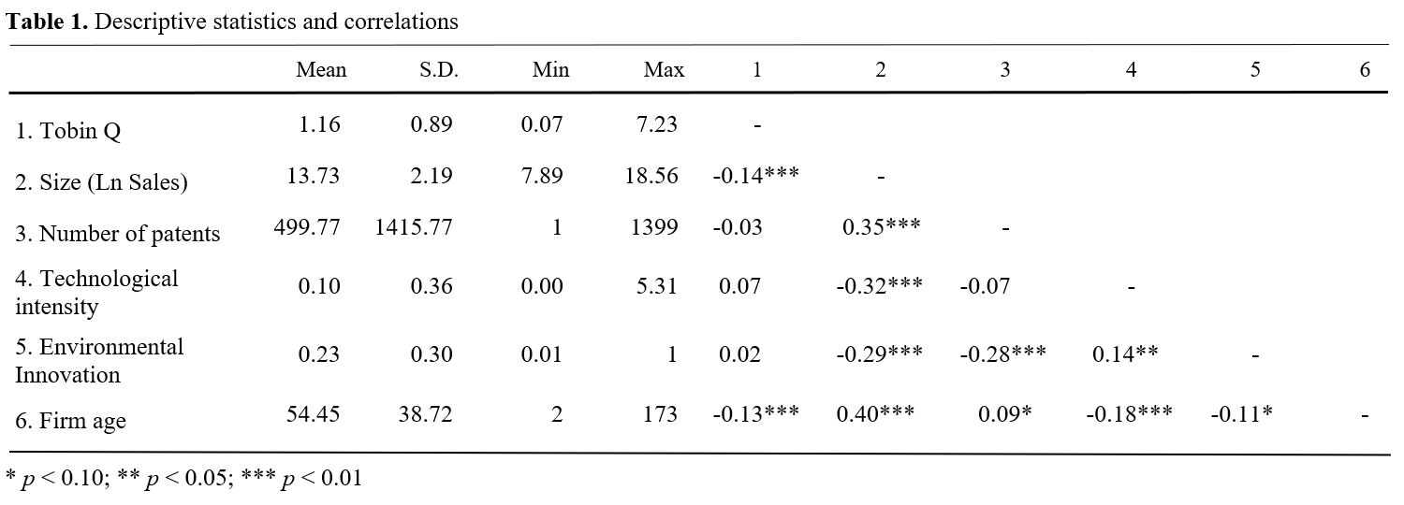

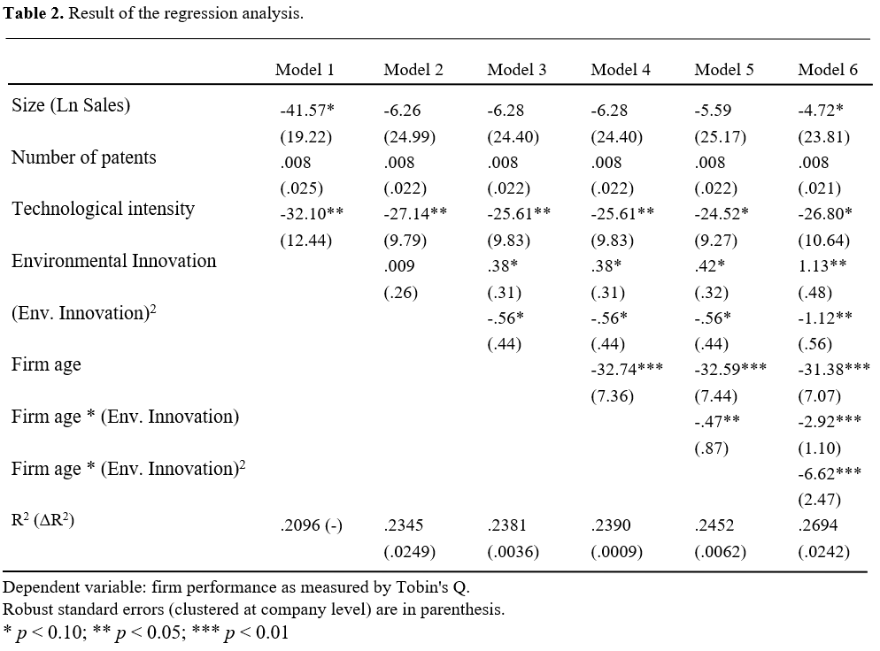

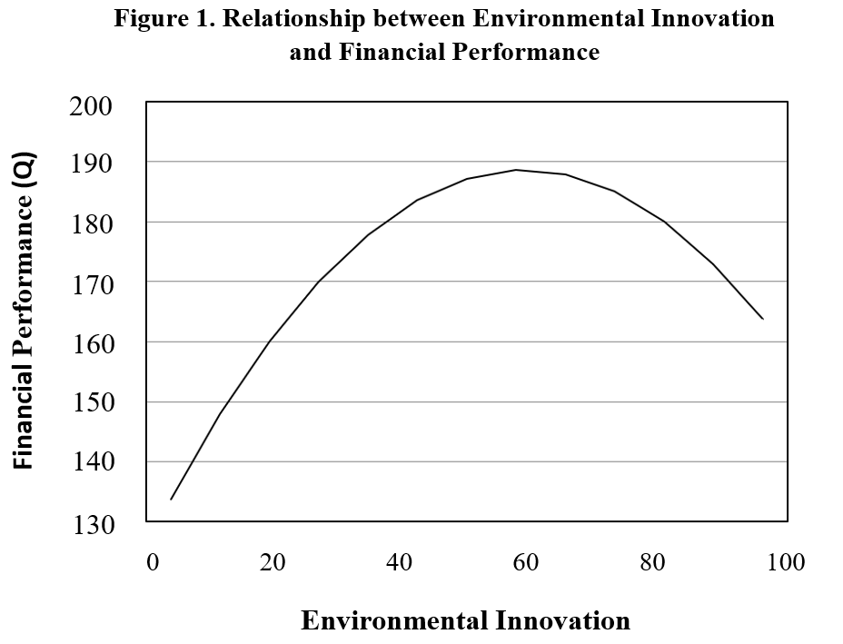

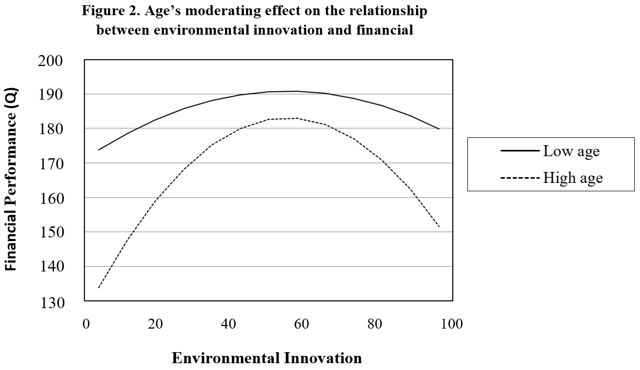

It is important to note that our analysis is based on granted patents, which is a process that tends to take several years (Belderbos, Faems, Leten, & Looy, 2010). Hence, all the years of our analysis are after the “.com” bubble burst and before the real-state crisis.
It is important to note that figures are plotted here for easy interpretation of the hypothesized relations between firm’s environmental innovation, firm performance, and firm age, which are precisely described in Table 2 (regression analysis). In this regard, Figure 2 graphs low and high levels of both environmental innovation and firm age, which have been calculated as the mean +/- the standard deviation of each variable (Dawson, 2014).

